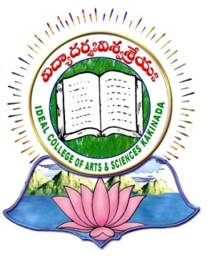 | IDEAL COLLEGE OF ARTS AND SCIENCES (A)
 | (A.P. Govt., Aided., Autonomous & NAAC B++)
 | Dr. P.V.N. RAJU VIDYAPRANGANAM
Samalkot Road, KAKINADA
East Godavari Dist
Andhra Pradesh

P.G. Department of Computer Science
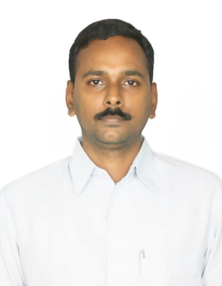

PROFILE

- Name : Nadella Sunil
- Designation and Place of work : Director,
P.G. Department of Computer Science
Ideal College of Arts & Sciences (A)
Kakinada-533003
A.P., INDIA.
- Date of Birth : 09-06-1978
- Nationality : Indian
- Mobile no : 9848325165
- E-mail : sunilnadella@gmail.com
- Address for Correspondence : Director
P.G.Department of Computer Science
Ideal College of Arts & Sciences, Vidyutnagar
Kakinada – 533 003, A.P., India.

- Details of Educational Qualifications:
Sl. No. | Course | University | Year | Specialization
01 | Ph.D | JNTU, Kakinada | pursuing | Computer Science
02 | M.Tech | JNTU, Kakinada | 2010 | CSE
03 | M.Phil | Andhra University | 2008 | Applied Mathematics
04 | PGDCS | Hyderabad Central University | 2006 | Computer Science
05 | M.Sc | Andhra University | 2000 | Applied Mathematics
06 | AP SET | Osmania University | 2014 | Mathematical Sciences
07 | AP SET | Andhra University | 2016 | Computer Science & Application

- Experience:

Sl.No | Designation | College | Date of Joining | Experience
01 | Director | P. G. Department of Computer Science | 05-03-2017 to  Till date | 7 months
02 | Associate Professor | P. G. Department of Computer Science | 20-02-2010 to  Till date | 6 years 8 months
03 | Lecturer | P. G. Department of Computer Science | 30-10-2000 to 19-02-2010 | 9 years 4 months

- Achievements
- Received Prof I Venkata Rayudu Shastabdi Poorthi Gold Medal from Andhra University
- Received Applied Mathematics prize From Andhra University
- T S R K Murthy Shastabdi Prize from Andhra University
- Stood University First in M.Sc Applied mathematics in the year 2000 in Andhra University
- Stood First in M.Tech CSE in UCEK, JNTUK
- Lecturer Ships Qualified in Mathematical Sciences & Computer Science and Applications

- Life Member in APSMS

- Regional/ State/National level Conferences/Workshops/Seminars

Workshops attended:
- A National Workshop on “Data Mining Applications through Clememtine”, TEQUIP, JNTUK, UCE, Kakinada, 18-03-2009 to 19-03-2009.
- A National Workshop on “Application of Image Processing & Security”, TEQUIP, JNTUK, UCE, Kakinada,
23-03-2009 to 24-03-2009.
- A National Workshop on “Mobile & High Performance Computing”, TEQUIP, JNTUK, UCE, Kakinada, 25-03-2009 to 26-03-2009.
- A National Workshop on “Big Data Analytics (BiDA2014)” held during
the period 22-24 August, 2014 at C R Rao AIMSCS, University of Hyderabad
Campus, Hyderabad.
- A one week National level workshop on “Research Challenges and Issues in Big Data and Cloud Computing” at UCE, JNTU, Vijayanaram from 27-01-2015 to 31-01-2015.
- A one week National level workshop on “Big Data Analytics” at UCEJ, JNTUH, Nachupalli, Karimnagar from 14-12-2015 to 20-12-2015.

National Conferneces:
- Presented paper in NCOITES-2010, Department of Computer Science, Adikavi Nannaya University, Rajahmundry, 22-10-2010 to 23-10-2010.
- Presented paper in NCATCS-2K12, Department of Computer Science, Ideal College of Arts & Sciences(A), Kakinada, 24-02-2012 to 25-02-2012.

- Administrative Experience:
Working as Director & HOD in P.G Department of Computer Science

- Training Programs/ Courses attended: - Nil-

(N. Sunil)

